COPD

- COPD is defined by two parameters – symptomatology and airflow obstruction (AO):
- Persistent respiratory symptoms (as opposed to only episodic symptoms in asthma)
- AO: not fully reversible and progressive
- COPD includes three major subtypes (which coexist with each other in any given patient):
- Chronic bronchitis – clinically defined by chronic cough and sputum production
- Emphysema – pathologically defined by destruction of alveolar walls
- Small airway disease – reduced cross-sectional area of small bronchioles
- Emphysema is a pathological term that describes some structural changes a/w COPD
- Types of emphysema:
- Centrilobular: a/w smoking; upper lobes and superior segments of lower lobes
- Panlobular: a/w AAT deficiency; lower lobes
- Paraseptal: centrilobular emphysema
- Pathophysiology
- Low FEV1 and low FEV1/FVC; not reversible with inhaled bronchodilators
- V/Q (ventilation / perfusion) mismatch leads to hypoxemia
- Increased RV (residual volume), or air-trapping
- RV / TLC ratio increases
- DLCO is reduced in emphysema
- History and examination
- Triad of symptoms: cough, sputum production and exertional dyspnea
- Recurrent acute exacerbations present with wheezing, cough, dyspnea
- Use of accessory muscles of respiration
- Tripod position
- Hoover’ sign
- Right heart failure (raised JVP and peripheral edema)
- Digital clubbing is not a feature of uncomplicated COPD
- Risk factors: Cigarette/ pollution/ chulla smoker/ AAT deficiency (‘Z’ allele- markedly reduced AAT)/ infections
- Diagnosis
- Compatible clinical feature
- Spirometry: FEV1 / FVC < 0.7
- CXR: Hyperinflation/ Flattening of diaphragm/ Tubular heart
- Assessment of severity and staging: ABCD assessment tool
- Treatment of stable COPD
- Smoking cessation: Nicotine replacement/Varenicline
- Inhaled bronchodilators (beta agonists and anticholinergics) given alone or in combination
- LTOT if PaO₂ ≤55 mmHg
- LVRS: Indicated- Upper lobe emphysema; Contraindicated-FEV1 < 20%, DLCO < 20%, diffuse emphysema
- Exacerbation of COPD
- Marked by worsening of dyspnea, cough, and wheezing
- Noninvasive positive-pressure ventilation improves clinical outcomes

  

POLYMERASE CHAIN REACTION ( PCR )

- The PCR allows the DNA in a single cell, hair follicle or spermatozoan to be amplified and analysed.
- Each cycle doubles the copy number of the amplified gene i.e. exponential increase
- Requirements
- Selected DNA strand- to be amplified
- Four deoxyribonucleotides- dATP, dGTP, dCTP, and dTTP.
- Primers- single-stranded oligonucleotides, 20-35 nucleotides long, complementary to the regions flanking target DNA.
- MgCl₂ and KCl
- Thermostable DNA polymerase, which can withstand a temperature up to 95º C. Taq polymerase, isolated from Thermus aquaticus is heat-stable and does not get denatured at high temperatures.
- Pfu is a thermostable enzyme having a proofreading activity (Taq polymerase doesn’t have proof reading activity) and is used for high fidelity DNA amplification.
- Procedure
- Denaturation (96ºC) - the target DNA to be amplified is heated to 95ºC .
- Annealing (50ºC) - the reaction mixture is cooled to 50ºC, so the primers can bind to their complementary sequences on the single-stranded DNA templates.
- Extension (72ºC) - the temperature is raised to the optimal temperature for Taq polymerase to synthesize new strands complementary to the original DNA.

The new strand growth extends in 5’-3’ direction across the target DNA to make complimentary copies of the target.
- Applications
  - Clinical diagnosis-
- Detection of inherited disorders, viral & bacterial diseases.
- PCR allows quantification and helps in detection for early diagnosis.
- Cancers and bacterial infections like tuberculosis can be detected with PCR
  - Prenatal diagnosis-
- For prenatal diagnosis of various disorders like sickle cell anemia, beta thalassemia, cystic fibrosis etc.
  - Comparison of a normal gene to its mutant form-
- PCR amplifies mutant DNA so that it can be studied and later used in the diagnosis
  - Forensic analysis-
- DNA isolated from single human hair, a tiny spot of blood, or a sample of semen is sufficient to determine whether the samples come from a specific individual.
  - Archaeology & Palaeontology-

- Types of PCR -
Simple PCR | - Standard PCR process
Nested PCR | - When DNA is amplified by PCR in a very low concentration as compared to the total DNA in the sample.  - In this process, two sets of primers are used to increase the sensitivity & specificity-  - Outer primers - first DNA is amplified using outer primers.  - Inner primers - it helps to amplify sequence inside the binding site of outer primers.
q- PCR (quantitative PCR) or Real-Time PCR | - In this DNA amplified is quantitated at the same time, not at the end of PCR as in conventional PCR.  Methods used are-  - Intercalating dyes- ethidium bromide & SYBR green (less toxic & more specific)  - Sequence-specific probes-generate fluorescence when hybridize to the target sequence-Taqman, Molecular beacon & fluorescence resonance energy transfer (Fret) probes.
RT – PCR (Reverse transcriptase PCR) | - cDNA is generated from an mRNA template by reverse transcription. This cDNA is amplified by PCR, which can be used to synthesize useful proteins.
Multiplex PCR | - Simultaneous multiplication of many targets using different primers in one reaction.

  

- COMMON NERVE INJURIES:
INJURY |  | NERVE INVOLVED | EFFECT | SPLINTAGE POSITION
 | Shoulder dislocation | Axillary nerve | Deltoid paralysis | Initially anatomical position, followed by abduction till recovery
 | Fracture shaft of humerus | Radial nerve | Wrist drop | Cock up splint in wrist dorsiflexion
 | Fracture medial condyle humerus | Ulnar nerve | Mild claw hand | Knuckle bending position with knuckle bender splint
 | Posterior dislocation of hip | Sciatic nerve | Foot drop due to peroneal component involvement | Foot drop splint, keeping the foot in neutral position
 | Knee dislocation, injury around neck of fibula | Common peroneal nerve | Foot drop | Foot drop splint
 | Monteggia fracture | Posterior interosseous nerve (PIN) | Finger drop | Cock up splint
 | Supracondylar fracture of humerus | Anterior interosseous nerve (AIN) > median nerve | Pointing index finger | Kiloh-Nevin sign (anterior interosseous) > pointing index (median nerve)

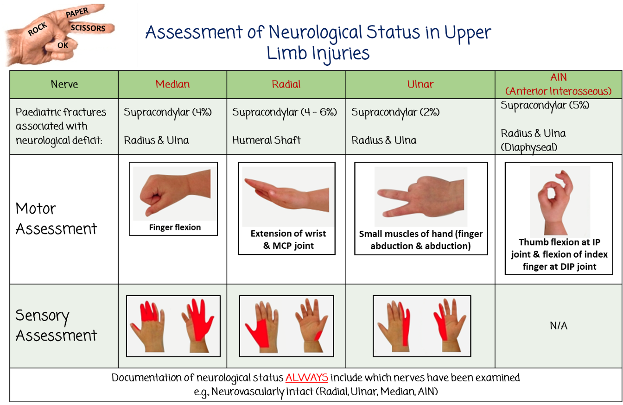
- Tests for ulnar nerve:
TEST | MUSCLE AFFECTED
Book test | Adductor pollicis
Card test | Palmar interossei
Igawa test | Dorsal interossei
Froment’s sign | Compensatory flexion by flexor pollicis

- Tests for median nerve:
TEST | MUSCLE AFFECTED
Ape thumb deformity | Thenar muscles
Pen test | Adductor pollicis brevis
Kiloh Nevin sign | Flexor digitorum profundus (FDP) + Flexor pollicis longus
Benediction hand | Flexor digitorum superficialis + Lateral half of flexor digitorum profundus

NERVE ENTRAPMENT SYNDROMES-
Nerve | Entrapment syndromes | Part of nerve involved
Median nerve | Carpal tunnel syndrome | Median nerve (at wrist) (most common) – superficial sensory branch is spared as it arises around 5 cm proximal to the carpal tunnel
 | Pronator syndrome | Median nerve (proximally compressed beneath ligament of Struthers, bicipital aponeurosis or origin of pronator teres or flexor digitorum superficialis)
Ulnar nerve | Cubital tunnel syndrome | Ulnar nerve (between two heads of flexor carpi ulnaris)
 | Guyon’s canal syndrome | Ulnar nerve (at wrist)
Brachial plexus | Thoracic outlet syndrome | Lower trunk of brachial plexus (C8 and T1) and subclavian vessels (between clavicle and first rib)
Sciatic nerve | Piriformis syndrome | Sciatic nerve
Lateral cutaneous nerve of thigh | Meralgia paresthetica | Lateral cutaneous nerve of thigh (can also get involved In McRoberts’ obstetric maneuver)
Superficial radial nerve | Cheiralgia paresthetica | Superficial radial nerve
Posterior tibial nerve | Tarsal tunnel syndrome | Posterior tibial nerve (behind and below medial malleolus)
Interdigital nerve of 3rd and 4th toe | Morton’s metatarsalgia | Interdigital nerve compression (usually of 3rd and 4th toe)
  

